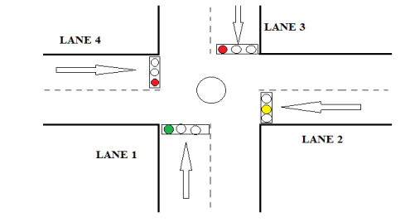

**Project Name:** "Traffic Management "

**Description:**

It is an advanced IoT project designed to predict traffic congestion with high accuracy by harnessing historical data and cutting-edge machine learning algorithms. This system aims to provide real-time traffic insights to commuters, city planners, and transportation authorities for efficient traffic management.

**Key Components:**

1. Historical Traffic Database: Accumulate a comprehensive historical database of traffic patterns, including congestion hotspots, accident data, weather conditions, and special events.

2. Real-time Data Streams: Collect real-time traffic data from IoT sensors, traffic cameras, GPS devices, and social media feeds.

3. Machine Learning Models: Develop sophisticated machine learning models, such as deep neural networks or recurrent neural networks (RNNs), to process historical and real-time data.

4. Predictive Analytics: Utilize predictive analytics to forecast traffic congestion at specific locations and times based on historical trends and real-time data.

5. IoT Traffic Beacons: Install IoT-enabled traffic beacons at critical intersections to communicate congestion predictions to drivers and autonomous vehicles.

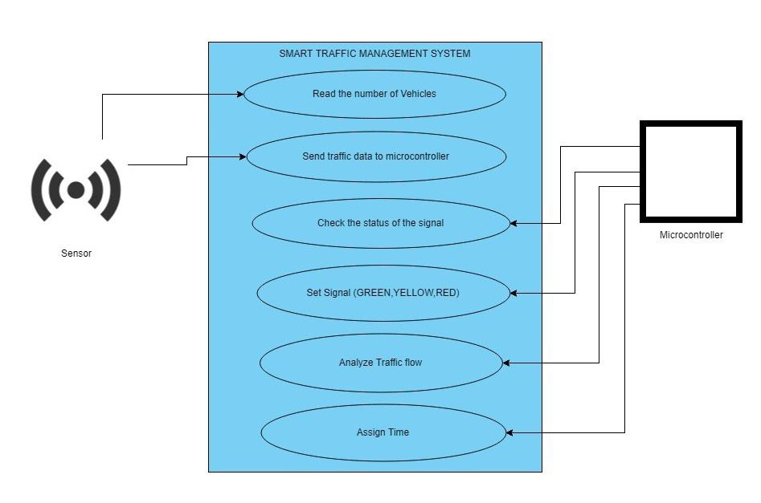**How It Works:**

1. Data Integration: Combine historical traffic data with real-time data streams, constantly updating the database.

2. Machine Learning Training: Train machine learning models to analyze historical data and recognize complex traffic patterns and congestion triggers.

3. Real-time Analysis: Continuously analyze incoming real-time data to identify congestion potential using the trained models.

4. Predictive Alerts: When congestion is anticipated, the system sends real-time alerts and suggested alternate routes to drivers through a mobile app or vehicle infotainment system.

5. Dynamic Traffic Signage: IoT traffic beacons at key locations display real-time congestion information and suggest alternative routes for drivers.

**Algorithm:**

Step 1:Start

Step 2: Sensors (Ultrasonic sensor) will read the no. of vehicles on each lane

Step 3:Turn on the green signal for all the lanes one after

another in a sequential manner. When signal is green for one lane, the

others will remain red.

Step 4:Compares the lane traffic count and gives signal sequentially due to their random time

respectively.(Ex :if a lane has more traffic ,green light will remain on that lane more

time than other lanes.).

Step 5:Jump to step3.

Step 6:All collected data of a day are stored in server.

**Benefits:**

- Efficient Commutes: Commuters can plan their journeys better by avoiding congested routes, reducing travel times, and stress.

- Improved City Planning: City officials can use data insights to make informed decisions about traffic infrastructure, road maintenance, and traffic signal timing adjustments.

- Enhanced Safety: Predicting congestion can help prevent accidents caused by sudden braking in traffic jams.

- Eco-friendly: Reduced idling and smoother traffic flow contribute to lower vehicle emissions and a greener environment.

- Data-Driven Smart Cities: The project contributes to the development of data-driven, smart cities with optimized transportation systems.